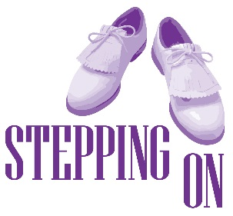
Date:

Interview Conducted By:

First Name

Surname

Address

Home Phone |  | Mobile Phone
Date of Birth |  | Gender
Emergency Contact Name

Emergency Contact Phone

GP’s Name

GP’s Address

GP’s Phone

Preferred Location

Language

Entry Criteria Checklist
Have you had a fall in the last year?

Are you concerned about falling or further falls?

Can you walk independently?

Do you use a walking frame?

Can you walk safely inside your home?

Do you have a progressive neurological condition?
Do you have a medical condition that might limit your ability to participate in the program?
Do you live in the community or an independent living unit?
Is a group offered in a suitable language?

Would the person be able to participate in a group setting?

Notes:

