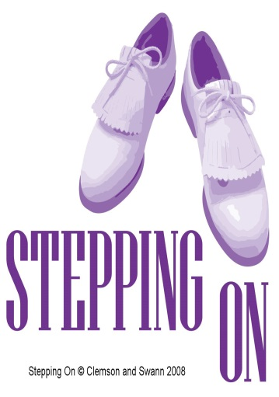
Stepping On’
For Carers
Reduce your risk of falling

The Team at Carers Support recognise that it is not easy to access health programs when your bigger responsibilities come first. With this in mind and knowing how important YOU are, we have arranged to specially deliver the internationally recognised ‘Stepping On’ program in a very unique way.
Carers are invited to attend this FREE program with the people they care for or alternately have respite provided from Carers Support to help you attend with other Carers.
• ‘Stepping On’is very enjoyable. You will have access to local health professionals and invited guests who will deliver a fun and interactive training program for people to prevent falls.
• This program includes practical simple exercises to improve your strength and balance.
• Participants attend the program for two hours a week for seven weeks, followed by a refresher session two months later.
• ‘Stepping On’ covers topics like exercise for strength and balance, safe mobility at home and in the community, home hazard reduction, vision, footwear, nutrition and medication.

Commences
Phone
Venue

